Week 5 Exercises: Mobile Device Features and Permissions
GitHub: https://github.com/mkzaw25101999/Mobile_Development_2_assignment

Part 1: Mobile Device Features and Expo
- They give JavaScript React Native apps access to native device and platform features (camera, location, sensors, notifications) through ready-made APIs, so we don’t have to write native Android or iOS code ourselves.
- Location (GPS), motion sensors (accelerometer) and the camera. (Others can be photos, microphone, haptics).
- An emulator is simulated and may lack real hardware like a true accelerometer or GPS, so values can be missing, faked, or inaccurate. A physical device has the real hardware, so features behave realistically.
- No, only features that access sensitive data or protected hardware (location, camera, microphone) need permission. Opening another app with Linking or reading the basic accelerometer usually doesn’t.

Part 2: Opening other Applications with Linking
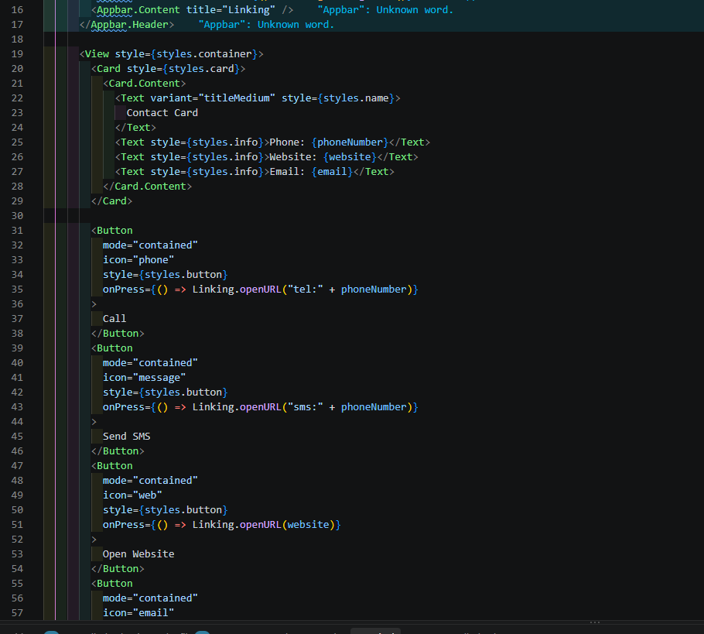
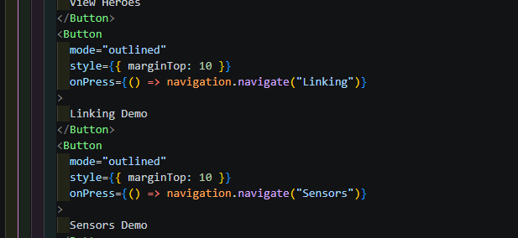

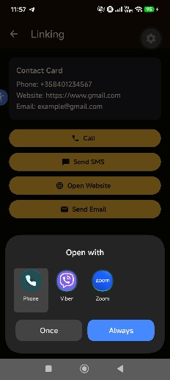
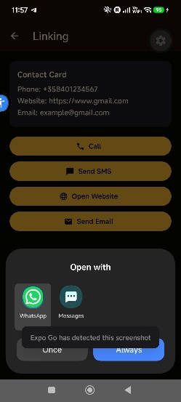
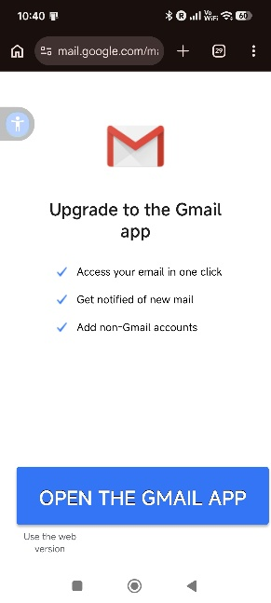
- No, it only asks the operating system to open the dialer; the phone app handles the actual call.
- The OS receives the URL, decides which installed app can handle that type of URL and opens it.
- It is a URL scheme that tells the OS the link is a phone number, so it opens the dialer.
- Each is a URL scheme for a different action: tel: opens the dialer, sms: opens messaging, mailto: opens email and https: opens a website in the browser.
- No, opening another app through Linking doesn’t need permission, because the app just asks the OS to hand off to another app.
Part 3: Device Sensors
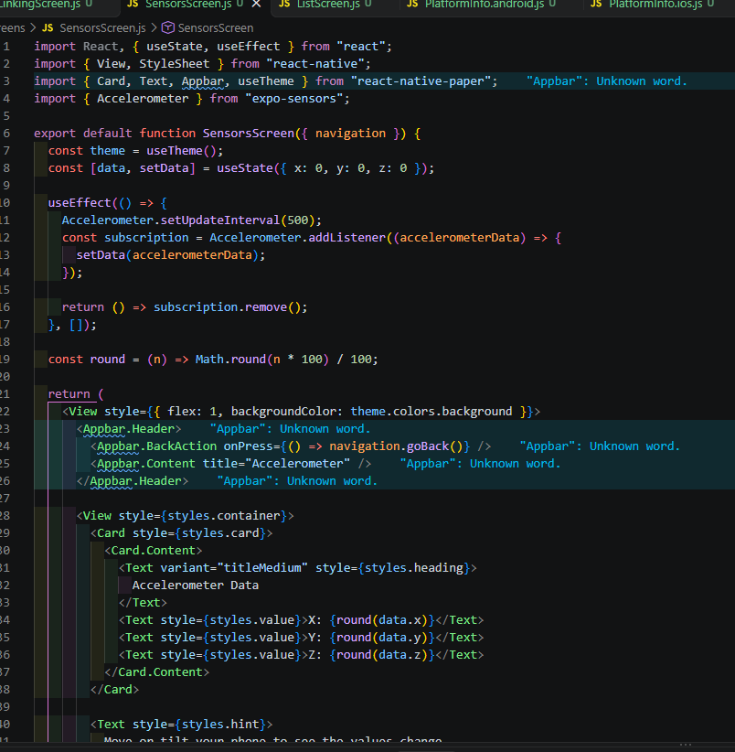
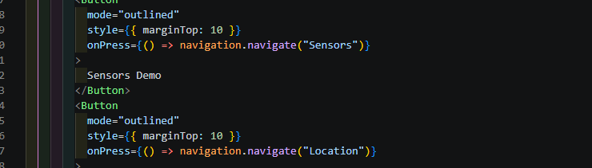
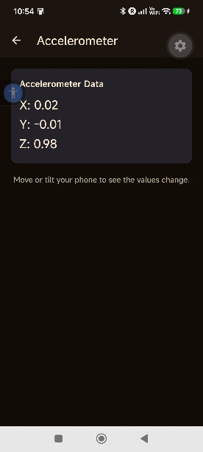
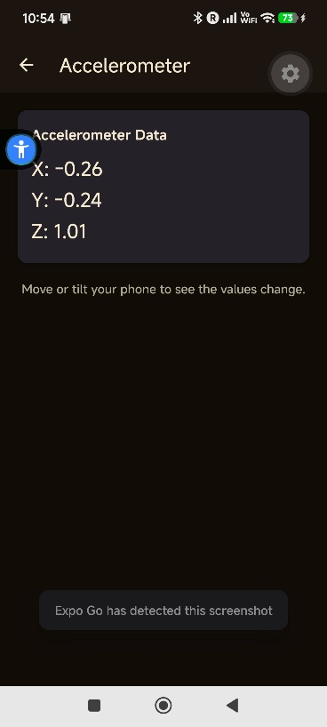
- A REST request is a one-time fetch that returns data once. Sensor data is continuous: the sensor keeps producing new values as the device moves, so we subscribe to a stream instead of requesting once.
- Registering a listener that receives new sensor values repeatedly as they are produced, instead of asking only once.
- To stop the sensor reporting when the screen is gone, which saves battery and prevents memory leaks and updates to a component that no longer exists.
- It runs when the component is removed or before the effect runs again. It removes the sensor subscription, which is the right place to clean up.
- No, the basic accelerometer doesn’t need a permission in this app.
Part 4: Understanding Mobile Permissions
- Because location is sensitive personal data. The suer should be the one who decides whether to share it, for privacy and security reasons. Giving every app automatic access would let apps track people without their knowledge.
- The operating system. React native paper, Expo, and React component can only trigger the request; the OS is what actually shows the permission popup and records the user’s choice.
- Handle it properly. It should show a clear message explaining the feature is not available and keep running normally, instead of crashing or getting stuck.
- No, a denied permission is a valid choice the user is allowed to make, not a bug. The app just has to handle that case properly.
- It respects the user’s privacy and builds trust. Asking at the moment the feature is used makes it clear why the permission is needed, so users are more likely to understand and grant it, rather than being asked for everything at startup.
Part 5: Location and Runtime Permissions
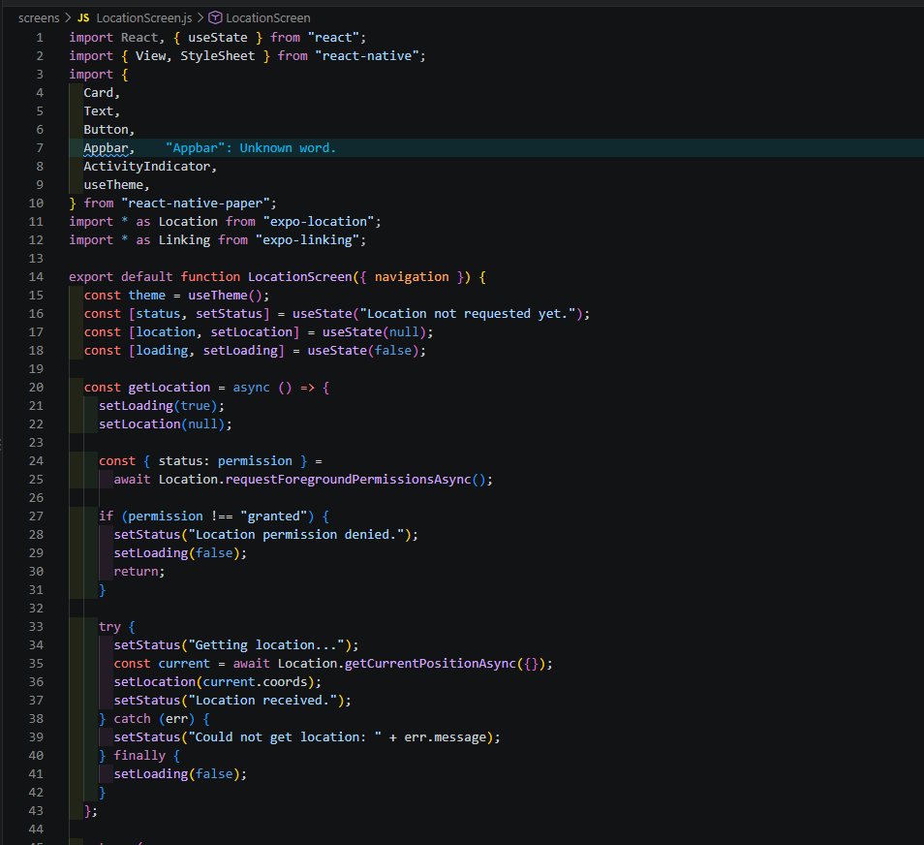
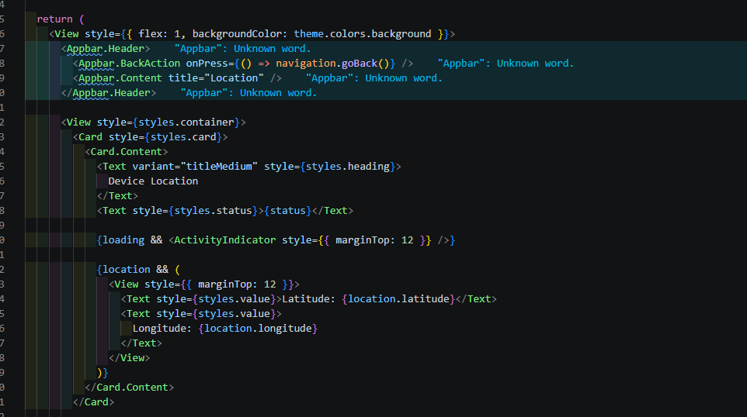
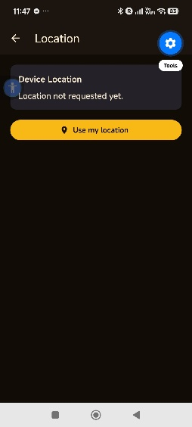
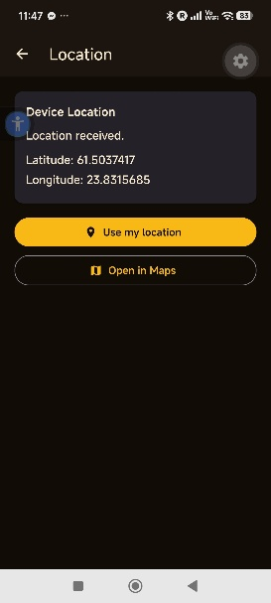

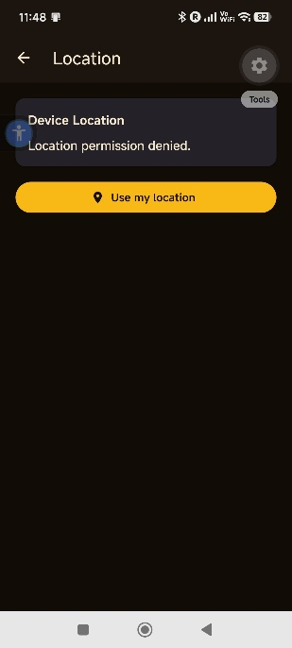
Part 6: Expo Go, Permissions and Application Configuration
- Application configuration is set up ahead of time and defines which capabilities and permission descriptions are built into my native Android or iOS app. A runtime permission request is the running app asking the user for access to a protected feature while the app is being used, for example, calling Location.requestForegroundPermissionAsync(). Configuration declares what the app is allowed to ask for: the runtime request is the actual asking.
- Because Expo Go already includes the native code for many Expo SDK libraries. This let me test device features like sensor and location straight away by scanning a QR code, without having to build my own native app first, which saves a lot of time while learning.
- Because not every Expo or third-party library is included in Expo Go. Some libraries need a custom development build, so a feature might not work in Expo Go even through my code is correct. Checking first avoids confusion when something fails for that reason.
- Because Expo Go already has the permission descriptions and native capabilities bundled in. my own build doesn’t include them automatically, so I have to declare the required permissions and settings in the app configuration. Otherwise, the feature that worked during development in Expo Go may not work in my production build.
Part 7: Small Extension
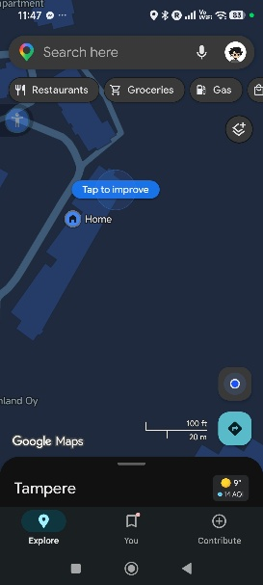
Part 9: Reflection
- Linking hands off to another app through the operating system, Sensors give a continuous stream of data that we subscribe to, and Location gives data once but requires a runtime permission. They are three different ways an app interacts with the device.
- Location, because it accesses sensitive personal data (the user’s position). The operating system requires explicit user consent before an app can read it.
- Show a clear message that the feature is not available and keep working normally, instead of crashing.
- A one-time async operation (like fetching the location once) runs, returns a result, and then finishes. A subscription (like the accelerometer) keeps delivering new values continuously until we remove it.
- Without cleanup, the subscription keeps running after the screen is gone, which wastes battery and can cause errors or memory leaks by updating a component that no longer exists. The cleanup function removes the subscription at the right time.
- It receives the URL, decides which installed app can handle it, and opens that app.
- Expo provides JavaScript libraries that act as a bridge to the device’s native features, so we can use sensors, location, and other hardware from JavaScript without writing native Android or iOS code.
- On a real phone the sensors and GPS actually work and the system permission dialogs appear, so we can test real device behavior. In a web browser those hardware features are missing or limited, so we cannot properly test them.
- I used Claude to help structure the Linking, Sensors, and Location screens and to explain permission and the subscription cleanup pattern. One suggestion I tested myself was denying the location permission from the phone settings to confirm the app showed “location permission denied”, instead of crashing, so I verified the behavior rather than just assuming it worked.

